Micralyne μTK User Guide
Remcho Research Group, Fall 2020
Latest revision: 2020-12-15

Table of Contents
1 Overview 3
2 Setup 3
2.1 Micralyne 3
2.2 Layout 4
2.3 Microfluidic Chip 5
2.4 GUI 5
3 Operation Details 7
3.1 Pretreatment of Channel Surface 7
3.2 Loading Microfluidic Chip onto the Instrument 8
3.3 Focusing Laser Beam 8
3.4 Pinched Injection and Separation 9
3.5 Rinsing Procedure 10
4 Issues and Fixes 11
5 Reference 12
Appendix 13
Optics Diagram 13
Operational Procedures 14

This guide is rewritten based on the contents in Derek Wong’s thesis[1]. Derek’s work contributes to sections 2.1, 2.2, 2.4 majorly in writing and chapter 3 and 4 partly as general idea. Bokun Zhou writes section 2.3, chapter 3 to 5 and appendix.

1 Overview

The Micralyne Microfluidic Toolkit (μTK) is an instrument built by Micralyne in the early 2000’s. It was designed for electrophoresis with laser-induced fluorescence (LIF) detection. It consists of high-voltage (HV) power supplies and LIF detection system. Controlled with LabView GUI, it integrates injection and separation/detection steps into single run, offering a convenient approach for lab-on-chip measurement.

Many groups have demonstrated lab-on-chip application with the Micralyne Microfluidic Toolkit. Some examples are shown in Table-1:

Table-1 A sample list of publications using Micralyne for lab-on-chip measurements
 | Title | Author | Analyte | Buffer
1 | Detection of nitrated benzodiazepines by indirect laser-induced fluorescence detection on a microfluidic device[2] | Sandra C. Bishop et al. | nitrated benzodiazepines | SDS/ boric acid/ sodium tetraborate/Cy5
2 | Dynamic coating for resolving rhodamine B adsorption to PDMS/glass hybrid chip with laser-induced fluorescence detection[3] | Jianzhen Kang et al. | rhodamine B | phosphate buffer with Triton X-100
3 | Separation and detection of VX and its methyl phosphonic acid degradation products on a microchip using indirect laser-induced fluorescence[4] | Vered Heleg-Shabtai et al. | VX (a nerve agent) and degradation products | carbonate buffer
4 | Surface modification of PDMS microchips using a double-chained cationic surfactant for efficiently resolving fluorescent dye adsorption[5] | Bingyan Han et al. | pyronin Y | sodium phosphate
5 | Estimation of pKa values using microchip capillary electrophoresis and indirect fluorescence detection  [6] | Christa A. Currie et al. | sulfanilamide, ethosuximide, etc. | 5-TAMRA

2 Setup

2.1 Micralyne
The Micralyne instrument has optical detection module and high voltage module. The optical detection module is supplied with a diode laser (green laser or red laser), a confocal microscope, a visual lens and a photomultiplier tube (PMT). The optics diagram can be found in appendix. In our setup, green laser is used. PMT gain is set by user and the PMT signal is sampled at up to 200 Hz. The high voltage module consists of an electrical board, a chip stage with HV probes, which are controlled using software compiled in LabView. The voltage of the probes ranges from 0 to 6 kV. While running, voltage and current are sampled at 50 Hz. The quick-switch allows for rise and fall times of up to 2 ms. The instrument has safety interlocks preventing overload, overcurrent or laser injury.

During operation, HV is applied onto each probe. Voltage and current are measured as a function of time. Laser beam is focused on the center of microfluidic channel. The reflected light is collected through bandpass filter and amplified by PMT. The intensity of PMT signal corresponds to the concentration of the fluorophore. The change of PMT signal indicates the movement of the analyte at the detection spot, showing as a peak (direct/normal fluorescence detection) or as a valley (indirect/inverse fluorescence detection).

2.2 Layout
In our setup, four probes are mounted on the plastics stage, as shown as item 9 in the Fig. 1. Details are explained in Table-2.
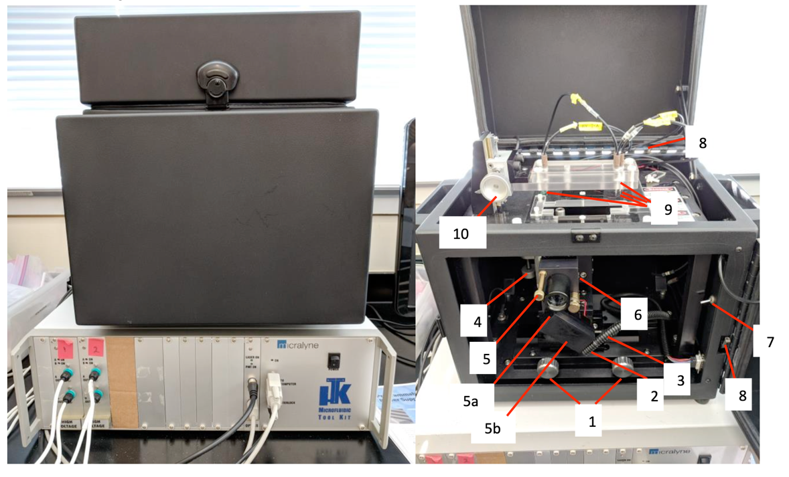
Fig. 1 Layout of the Micralyne Instrument

Table-2 Details about the Micralyne Instrument
 | Purpose | Details
1 | Knob for fastening optical stage | Usually fastened. Adjust it if needed.
2 | Knob for X adjustment | To be fine-tuned each time
3 | Knob for Y adjustment | To be tuned each time
4 | Knob for Z adjustment | To be fine-tuned each time
5 | Screw pin for holding optics | Pull back, then choose Visual Lens or PMT
6 | Pin for switching modes | In—Focus mode; Out—Scatter mode
7 | Switch to turn on LED if laser’s on | -
8 | Safety interlock | -
9 | Probes on stage | Platinum wire; The stage can be customized.
10 | Knob for adjusting probe height | Make sure the probe is not bent while lowering

2.3 Microfluidic Chip

The microfluidic chip in use is purchased from ChipShop (product code: 02-0750-0082-01 PMMA or 02-0750-0082-02 Topas). The cross-shaped channel is 50 µm in width and depth. The separation channel is 87mm in length. The chip has Luer interfaces, with hole diameter of 1.0 mm.

In our setup, the chip in use is made by Topas, which is a cyclo-olefin copolymer (COC). It is completely non-polar as well as amorphous. It can be used with polar solvents, silicone oils and aqueous solutions including acid and bases. It cannot be used with non-polar solvent.

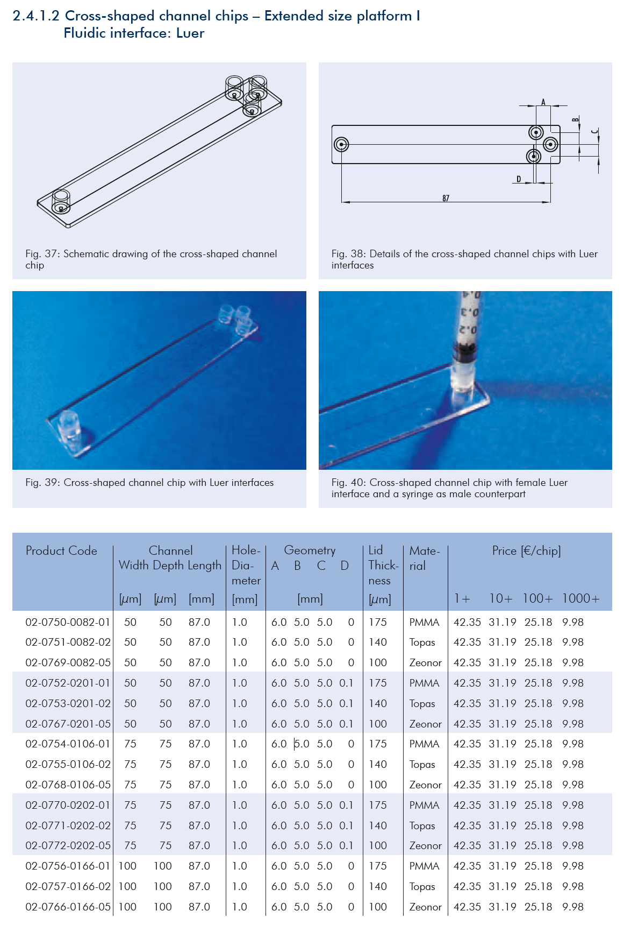
Figure-2 Dimension of the microfluidic chip made by ChipShop, excerpted from product catalog

Table-3 Specification of the microfluidic chip in use

2.4 GUI
The LabView GUI, Shortcut to uTK editor locates on the right side of the desktop. It usually takes less than one minute for the software to load and communicate with the instrument. The control program (CP) is compiled in LabView 2012 GUI. The GUI appears as the follows,

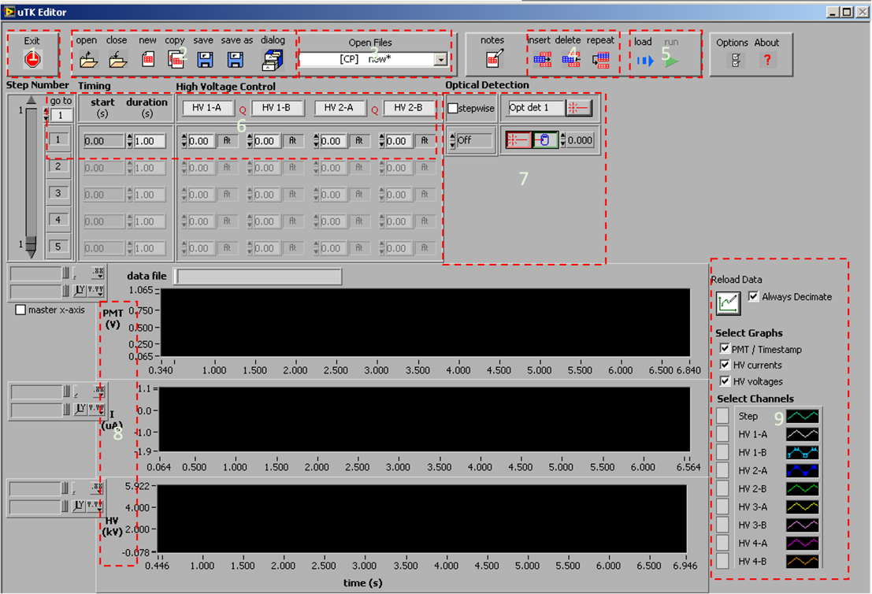
Fig. 3 The µTK editor GUI

Table-4 Functions in the µTK editor GUI
 | Function | Details
1 | Exit | Exit the program when finished
2 | File management | Open/close files  Dialog: batch saving  Notes: note for CP or Data file
3 | File in use | *: unsaved  [CP]: control program file  [Data]: data file
4 | Edit steps | Insert/delete/repeat steps
5 | Operating command | Load the CP program then run
6 | Control Program: duration and voltage | Set duration of each step  set voltage of each probe: gnd ground, flt floating  HV-1 injection channel  HV-2 separation channel
7 | Control Program: duration and voltage | Set laser-on and PMT gain by step
8 | Data: PMT, I and HV | Adjust scales on the left side, or manually input  Right click for export options (Fig. 4)
9 | Data: legend | Choose data in display

Functions in µTK editor is explained in Table-4. Note that [CP] at the beginning of the file name means control program, which saves the step setup, whereas [data] saves the current/voltage/PMT data for each operation. If one were to use the same setup for multiple time, make sure to save the data properly and re-run the same CP file.

In Box-7, the button right next to “opt det 1”, turns on the laser when the µTK is not running. The gain of PMT is usually set to be 0.3 – 0.5 (maxes out at 0.8). The sampling frequency of PMT is usually set at 50 Hz but is up to 200 Hz.

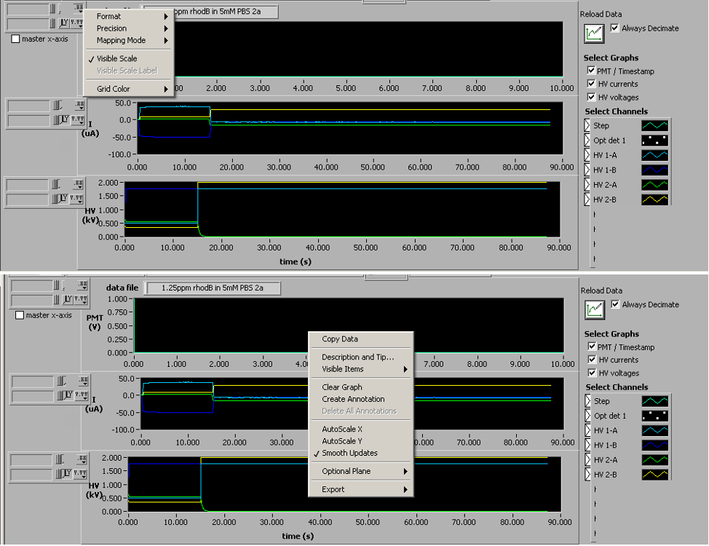
Fig. 4 Right-click menu for the graphs

3 Operation Details

The purpose of this chapter is to describe the details about some of steps. For a sample experiment, please refer to the standard operation procedure (SOP) in the appendix.

3.1 Pretreatment of Channel Surface
Pretreatment of channel surface is critical for reproducibility. For aqueous solution, it requires hydrophilic surface to achieve proper flow. Here, we use methanol to improve the surface condition. Fill the wells with methanol, then use vacuum to fill up the channel. Repeat such procedure at least 3 times. After this, introduce the buffer of choice, flush in the same manner for several times to properly conditioning the channel.

Make sure to rinse the channel often, before and after use, to maintain good condition.

3.2 Loading Microfluidic Chip onto the Instrument
Slide microscope chip into the slot. Hold it against to the right, then, fasten the screw. Make sure the chip is not bent or tilted, as a bent or tilted channel would add unwanted backflow and affect the electroosmotic flow, resulting poor reproducibility[7]. Carefully lower electrodes into the wells, till immersed, but not in touch with the inlet of the channel.

Make sure to clean the electrode with IPA after use.

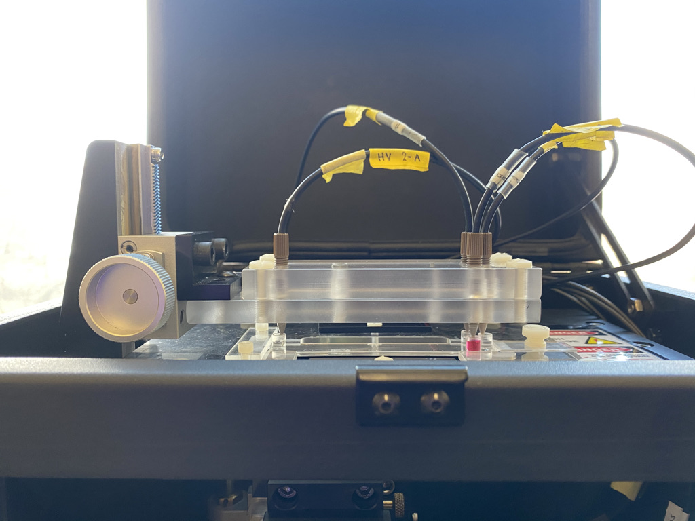
Fig. 8 Loading the microfluidic chip onto the instrument

3.3 Focusing Laser Beam
As illustrated in Fig.1, the position of laser can be adjusted in X, Y, Z direction. Usually, Y direction does not require adjustment, as it translates along the microfluidic channel, though it might slightly shift. It is better to fix Y distance, making sure it does not reflect on any structure on the chip. X direction should be adjusting each time when the chip moves, especially when re-install the chip. Note that the channel width is only 50 microns, it requires less than one-revolution precision, to properly align in the X direction. Look at the laser spot on the chip, roughly align it to the center of the channel by translating the stage back and forth. Fine tune at the position to find the spot where it has the most reflection, that is when the laser beam hits the edge of the channel and scattered. It can be verified when the entire chip appears illuminated and also the view in objective lens appears brightest. (The brightness largely depends on the concentration of fluorophore at site). Comparisons between aligned (illuminated) view and not aligned view in X direction is shown in Fig. 8.

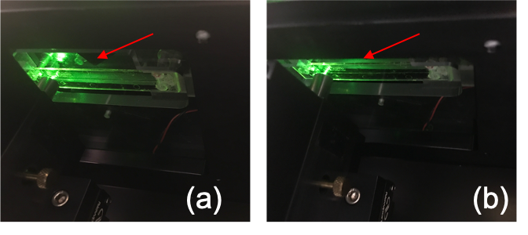
Fig. 8 (a) Laser beam is focused at the center of the channel. (b) Laser beam is off-focused.

It only takes about 1 and ¼ revolution in Z direction, for the laser spot moves from the bottom to the top of the chip. Views from the visual lens can be categorized in Table-4. Laser beams follow a Gaussian profile. To focus for the most overlap, the spot of beam should be in the middle of the channel, somewhere between position-3 and position-4. It is recommended to find the edge of the channel first. Then, by adjusting the X-direction off-focus, as the stage moves up and down in Z direction, we can see the green laser spot gets larger. Adjust the stage back in focus at X-direction, then, try to make the laser spot overlap with the channel as much as possible. In our setup, the view when laser is focused properly appears as Fig. 9.

Table-4 Views in the visual lens when adjusting in Z direction
From the bottom to the top  (adjust clockwisely) | Views in the visual lens | Meaning
Position-1 | Clear particles | Focused at the dust on the lens
Position-2 | Particles become obscure | Off-focus
Position-3 | Channel appears | Approaching the top of the channel
Position-4 | Clear edge of the channel | Focused at the top of the channel
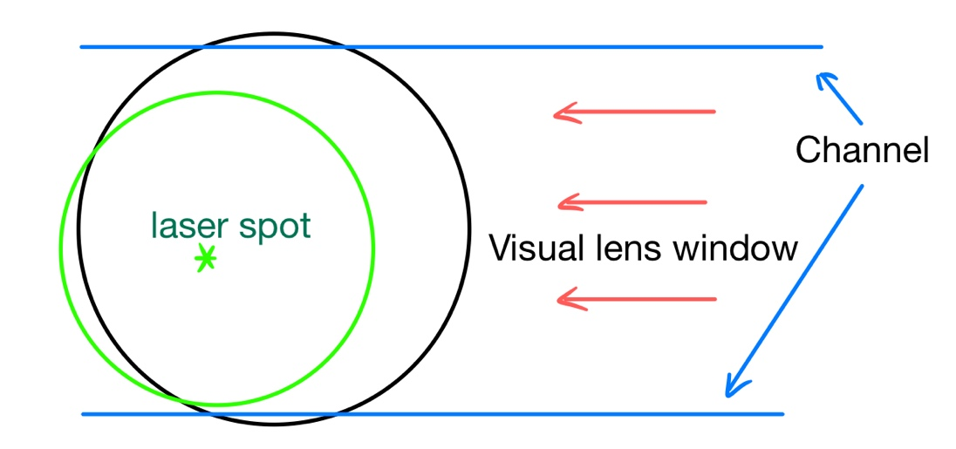
Fig. 9 Illustration of the expected view when laser is focused with current setup

3.4 Pinched Injection and Separation

A good injection can significantly increase the resolution of the electrophoretic injection. Instead of simply inject the sample into the cross-section, pinch the injection by introducing a focusing stream on both sides of the injection channel. It is realized by adjusting voltage at B and BW. When pinched injection is used, a step of flow reverse before separation can also be added to further improve the resolution of the injection, i.e., to control the volume of the injected sample[8], [9].

Experiments are needed to optimize the exact voltage value for various sample and buffer. Generally, for injection, the sample flows from S to SW, whereas the buffer is held in the separation channel. High HV is set a S to make sure enough analyte flows into the cross section. Small voltage is set at SW to contain the sample back in the cross section instead of flowing towards SW. The potential of B is also elevated, preventing the sample flows away from the cross section, leaving only the SW is grounded.

For separation, the injected sample flows along the separation channel from B to BW, whereas the injection channel holds still. Only BW is grounded to make sure all the injected sample is flushed through separation channel. Ideally, the potential between S and SW holds the same, functioned as a plug to minimum flow in the injection channel. In reality, the voltage should be adjusted slightly off to achieve such. It should also be higher than the B to prevent buffer flows into the S/SW disturbing the fluid.
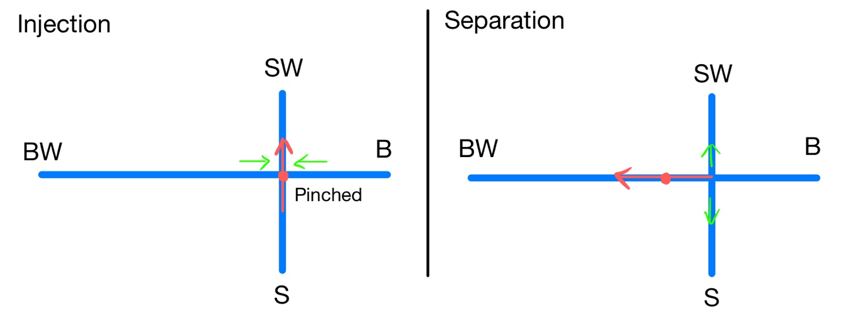
Fig. 10 Illustration of pinched injection and separation

3.5 Rinsing Procedure

Single chip can be use repeatedly, a rinsing procedure is prompted:
- Remove solutions in BW and B, replace with buffer solution
- Apply high voltage to BW, ground B, for at least 300 seconds
  - Elevated potential of S and SW, preventing backflow.
  - Increase the HV applied to BW by step, to make sure all the analyte in the separation channel is flushed out.
  - When the current is stable and no fluorescent signal change is detected, move to next step.
- Remove solutions in BW, B and SW, replace with buffer solution.
  - Apply bias similar to the injection step but smaller, hold for a while to verify if the current is stable. Compare the results with the original
  - Apply the same bias to probes, hold for a while to establish equilibrium
  - If current is severely off, thorough cleaning is needed.

Table-5 Rinsing Procedure
Reservoir | Potential (kV)
 | Rinse | Restore | Equilibrium
Duration | 300 s in total | 50 s | 10 s
Sample (S) | 0.5 | 0.5 | Ground
Buffer (B) | Ground | 0.5 | Ground
Sample Waste (SW) | 0.5 | 0.8 | Ground
Buffer Waste (BW) | 1.5/2.0/2.5 | 0.5 | Ground

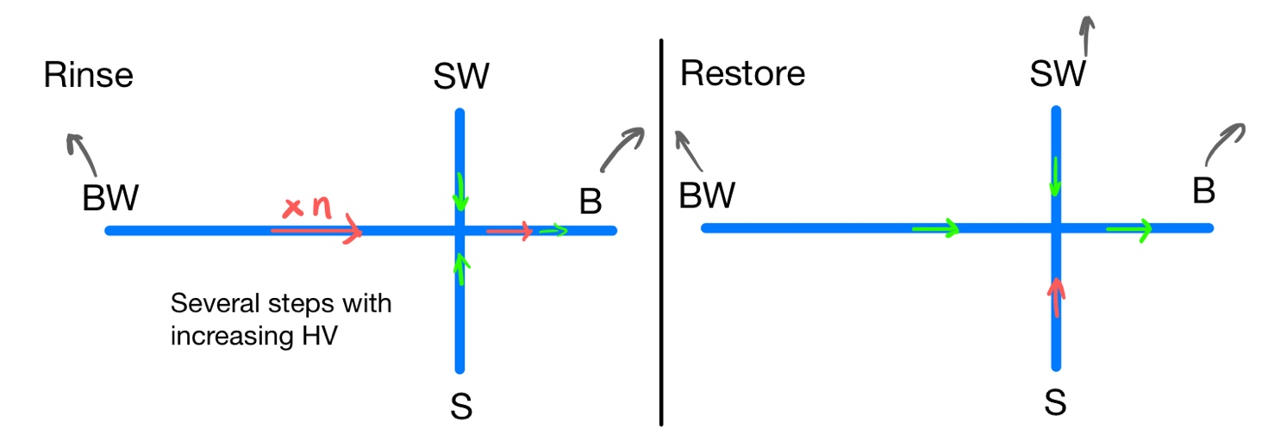
Fig. 11 Illustration of rinsing procedure

4 Issues and Fixes

- Make sure to check all electrical cable is properly connected, if the instrument has not been used for a long time.
- It is recommended to warm up the laser for at least 10 minutes to get a stable laser output and/or detection.
- Wear laser safety goggles to protect eyes, when focusing the laser beam.
- Make sure the PMT is in position, instead of the object lens.
  - The noise level of PMT is at about 0.1 V. If the signal is always at noise level, it is probable due to the PMT is not in position.
- Make sure to load the CP before Run.
- The interlock of the top lid prevents laser to be turned on when the lid is open. The interlock of the bottom lid prevents the PMT working when the lid is open. Make sure to close the lids before operation and to turn off PMT and/or laser before open the lids.
- To increase reproducibility, pretreatment is critical as well as regular rinsing.
- It is suggested that use filter for both sample and buffer to prevent clogging.
- The use of methanol has two purpose. For one, rhodamine B has slightly better solubility in ethanol (15 g/L) than in water (8-15 g/L). Methanol helps to remove rhodamine B more efficiently. Secondly, it improves hydrophilicity, helping the electroosmotic flow during operation.
- The current in display is not displayed zero-sum, it is because the length of each channel is different. When the same voltage is applied at different distance, the current is different because it is inversely proportional to resistance, which is roughly distance in our case, since the cross section of the channel is the same, barring the variation of concentration in the fluid. The net charge transfer should still be zero.
- The LabView GUI cannot be upgraded to the latest version before the OS is upgraded to Windows 10.
  - Current version: LabView 2012
  - Newest possible version on windows 7: LabView 2014
  - Latest version: LabView 2020 (available on Windows10)
  - Suggestions:
    - Use personal laptop to upgrade and test the GUI
    - Upgrade OS by school

5 Reference

[1] D. H. Wong, “Restoring and Updating the Micralyne μTK,” p. 50.
[2] S. C. Bishop, M. Lerch, and B. R. McCord, “Detection of nitrated benzodiazepines by indirect laser-induced fluorescence detection on a microfluidic device,” J. Chromatogr. A, vol. 1154, no. 1–2, pp. 481–484, Jun. 2007, doi: 10.1016/j.chroma.2007.05.004.
[3] J. Kang et al., “Dynamic coating for resolving rhodamine B adsorption to poly(dimethylsiloxane)/glass hybrid chip with laser-induced fluorescence detection,” Talanta, vol. 66, no. 4, pp. 1018–1024, May 2005, doi: 10.1016/j.talanta.2005.01.002.
[4] V. Heleg-Shabtai, N. Gratziany, and Z. Liron, “Separation and detection of VX and its methylphosphonic acid degradation products on a microchip using indirect laser-induced fluorescence,” ELECTROPHORESIS, vol. 27, no. 10, pp. 1996–2001, May 2006, doi: 10.1002/elps.200500683.
[5] B. Han, Y. Xu, L. Zhang, X. Yang, and E. Wang, “Surface modification of poly(dimethylsiloxane) microchips using a double-chained cationic surfactant for efficiently resolving fluorescent dye adsorption,” Talanta, vol. 79, no. 3, pp. 959–962, Aug. 2009, doi: 10.1016/j.talanta.2009.04.030.
[6] C. Currie et al., “Estimation of pKa values using microchip capillary electrophoresis and indirect fluorescence detection,” J. Chromatogr. B, vol. 824, no. 1–2, pp. 201–205, Sep. 2005, doi: 10.1016/j.jchromb.2005.07.035.
[7] H. J. Crabtree, E. C. S. Cheong, D. A. Tilroe, and C. J. Backhouse, “Microchip Injection and Separation Anomalies Due to Pressure Effects,” Anal. Chem., vol. 73, no. 17, pp. 4079–4086, Sep. 2001, doi: 10.1021/ac010217r.
[8] A. Persat, T. Zangle, J. Posner, and J. Santiago, “On-chip Electrophoresis Devices: Do’s, Don’t’s and Dooms.,” Lab. Chip, p. 8.
[9] C. S. Henry, “Microchip Capillary Electrophoresis: An Introduction,” in Microchip Capillary Electrophoresis, vol. 339, New Jersey: Humana Press, 2006, pp. 1–10.

Appendix

Optics Diagram

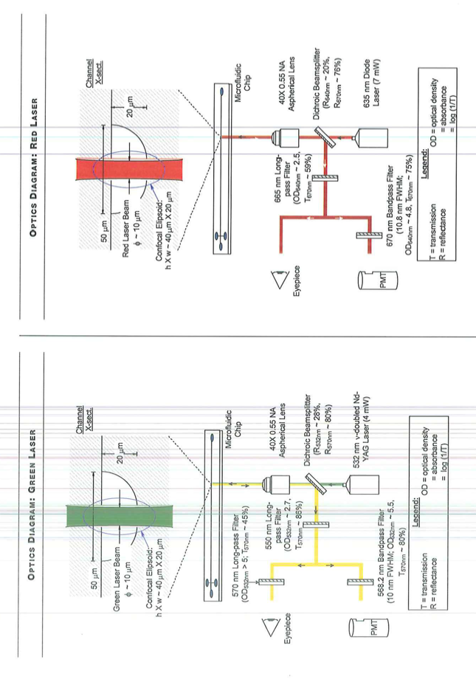

Operational Procedures
The SOP is written for step-by-step operation. For more information about the system, please refer to the Micralyne User Guide.

Preparation
- Prepare sample and buffer solution at given concentration.
- Before started, check that all cables for the Micralyne instrument are properly connected, then turn on the PC and the Micralyne.
  - Including HV input, power supply, data cable
- Log in to the PC, open LabView at the desktop
  - Password: remcholab
  - It usually takes a few seconds to load the GUI
- Turn on the laser by clicking the laser-on button in the µTK editor (shown in the red box). Warm up the laser at least 10 minutes before experiments.
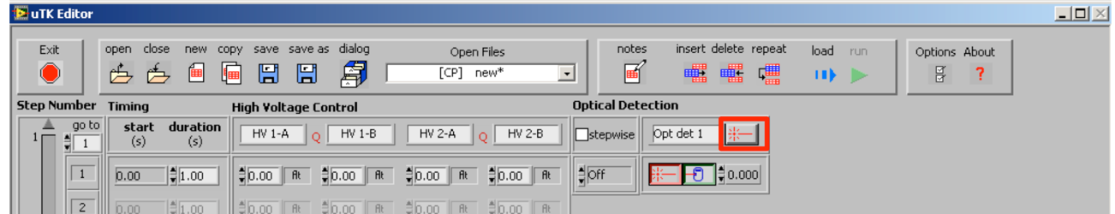
- Load buffer onto microfluidic chip
  - Use automatic pipet to load buffer into the SW, B, BW
  - Use vacuum on four wells to make sure the channel is filled with buffer
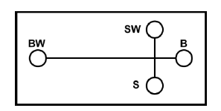
- Load sample onto microfluidic chip
  - Use automatic pipet to inject sample into the S
  - Add buffer to S, if needed
- Put the microfluidic chip onto the Micralyne, lower the probes
  - Make sure only the tip of probes is immersed into the solution
  - Be careful not bending the metal tip
- Fasten the screws on the right, then close the lid
- Check focusing
  - Adjust x, y knobs, to roughly find a brightest spot
  - Adjust z knob, to find the laser spot covers the area
  - Before closing the door, make sure PMT is on the detection position, instead of the Objective Lens.

Injection
Reservoir | Potential (kV)
 | Injection | Separation
Duration | 15 s | 120 s
Sample (S) | 0.5 | 1.76
Buffer (B) | 0.4 | 1.76
Sample Waste (SW) | Ground | 2.00
Buffer Waste (BW) | 0.55 | Ground

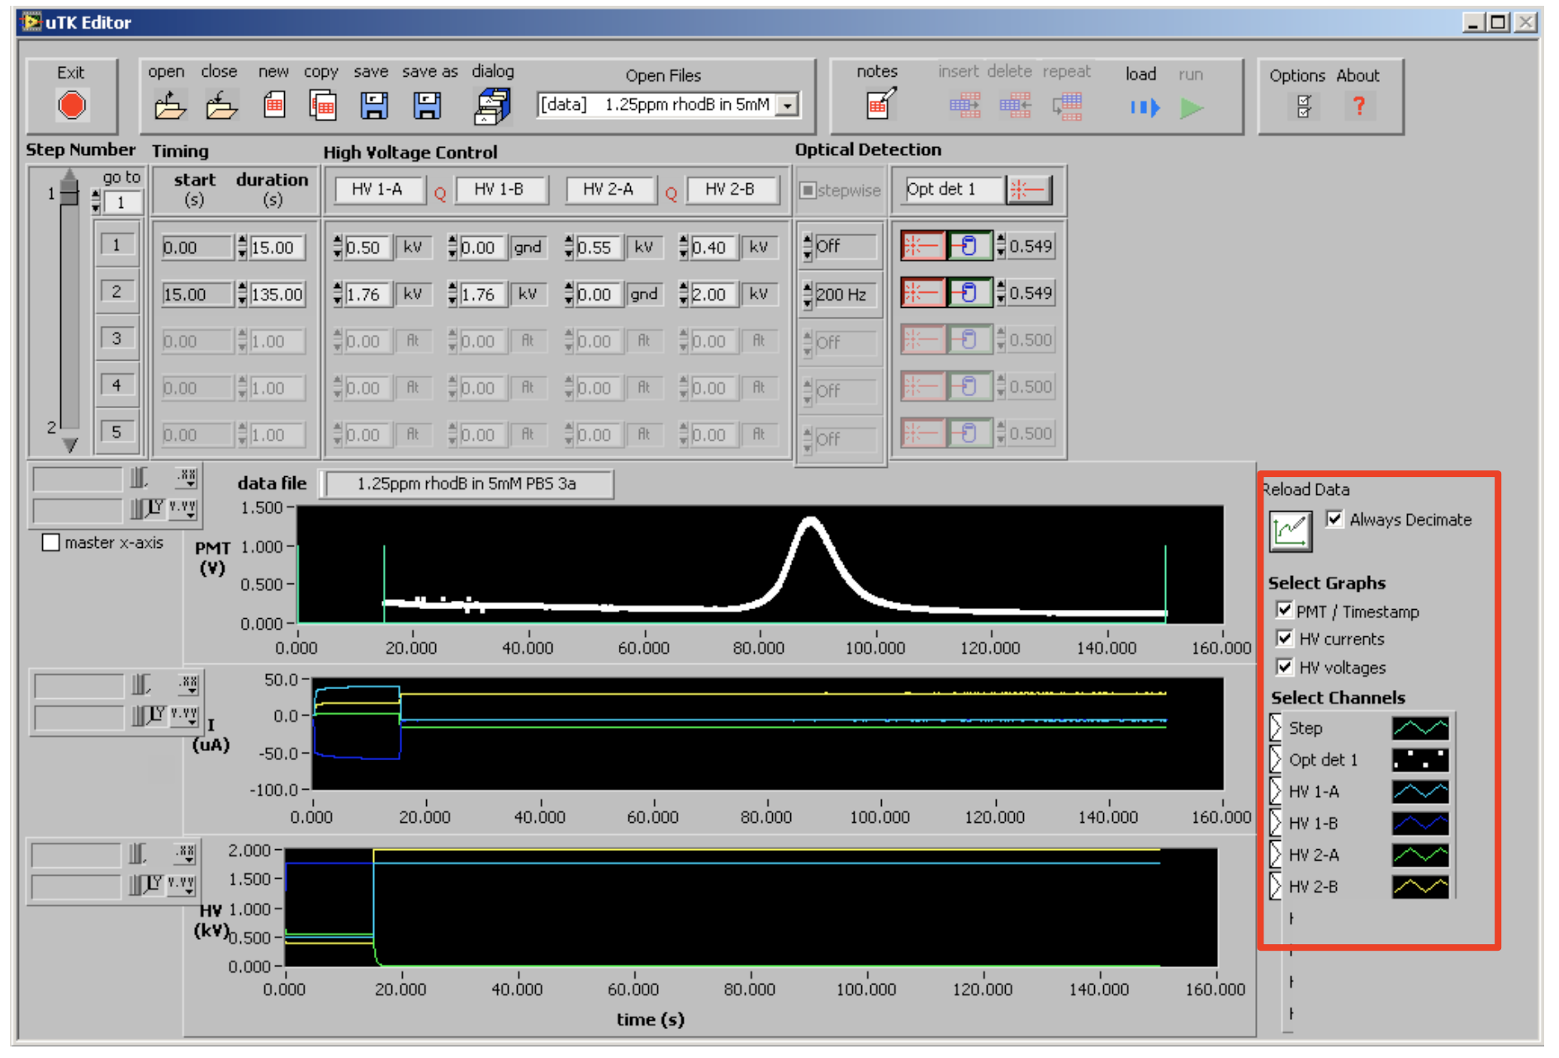

- Set up the program
  - Adjust the voltage
    - In order to let sample flows into the cross channel, ground the HV 1-B (SW) and apply a small HV on HV 1-A (S).
    - In order to contain the sample within the cross region, a potential difference should be applied on the separation channel between HV 2-A (BW) and HV 2-B (B)
      - $V_{BW}>V_{B}$, so that there is no flow in the separation channel.
    - The maximum current is 100 µA. A good flow often has current of a few to tens µA. Adjust the voltage to make sure current is within the limit.
  - Adjust the injection time
    - It is recommended to use 15 – 20 seconds for the injection
  - Adjust the gain of PMT
    - The gain is usually set as 0.4.

Separation/Detection
- Set up the program
  - Add step-2 in the control program for separation
  - Adjust the voltage
    - It is important for the HV 1-A (S) and HV 1-B (SW) has the same voltage, to minimize excess injection.
    - It is important to set relatively high voltage at HV 2-B (B), so that the analyte/sample can be flushed into the detection region, retaining a narrow and tall peak.
    - The maximum current is 100 µA. A good flow often has current of a few to tens µA. Adjust the voltage to make sure current is within the limit.
  - Adjust the detection time
    - It is recommended to use at least 100 seconds for the analytes arriving at the detection region
- Click Load to load the program to the instrument, then click Run for the operation to start
- Watch real-time results, adjust the axis if needed. For normal fluorescence detection, a signal peak should appear. Check final results at the end.
- Click the save button to save the data, which stored differently than control program (CP).
- Right click on each graph to export the results to excel, for future analysis and plotting, if needed

Cleaning
The microfluidic chip must be clean thoroughly and stored in dry and sealed to avoid moisture affect the surface or particles to block the channel.
- Use automatic pipet to remove remaining solution from S, SW, B, BW.
- Use automatic pipet to fill them with DI water, then remove the water. Repeat it for at least three times.
- For thorough clean, use ultrasonic bath
  - Use tweezer to put the microfluidic chip into a plastic bag, filling with DI water. Then, put the plastic bag in ultrasonic bath, for about 10 minutes.
  - Use tweezer to take out the microfluidic chip. Wipe out the excess DI water on the surface. Use pipet to remove solutions in the wells. Use vacuum to dry the wells and the channel
- Pipet methanol into the wells, then use vacuum to fill methanol into the channel, to improve the hydrophilicity of the channel. Let stand for a while, then use vacuum to dry the wells and the channel.
- Store the chip back in the sealed bags to avoid contamination.

Finishing
- When finished, turn off the laser by click the laser button. Exit the GUI and turn off PC. Turn off the Micralyne.
- Wipe the probe tip with IPA to remove residual solutions

The current LabView version is upgraded by Derek Wong.

